Project development phase

Project development delivery of sprint -4

|  |  |
| --- | --- |
| Date | 14 October 2022 |
| Team ID | PNT2022TMID45285 |
| Project Name | IOT Based safety gadget for child safety monitoring and Notification |

**Major problem:**

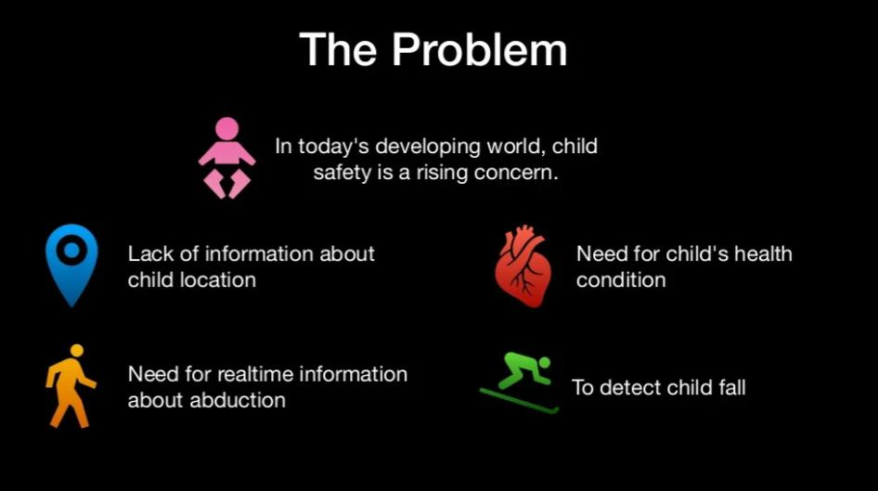

*Lack of information about child location*

*To detect child fall*

***Stackholders:***

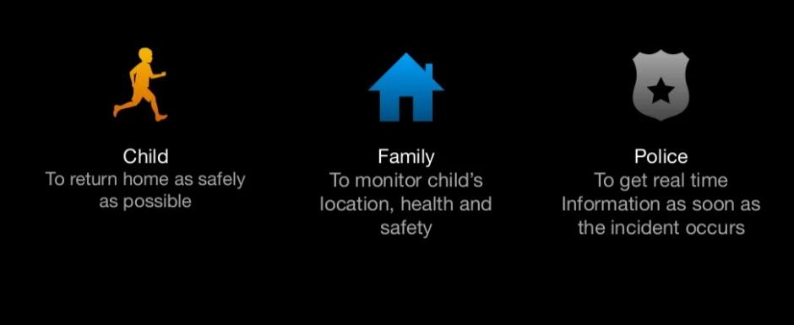

*Child:To return home as safety as possible*

*Family:To monitor child location, health and safety*

*Police:To get real time information as soon as the incident occurs*

*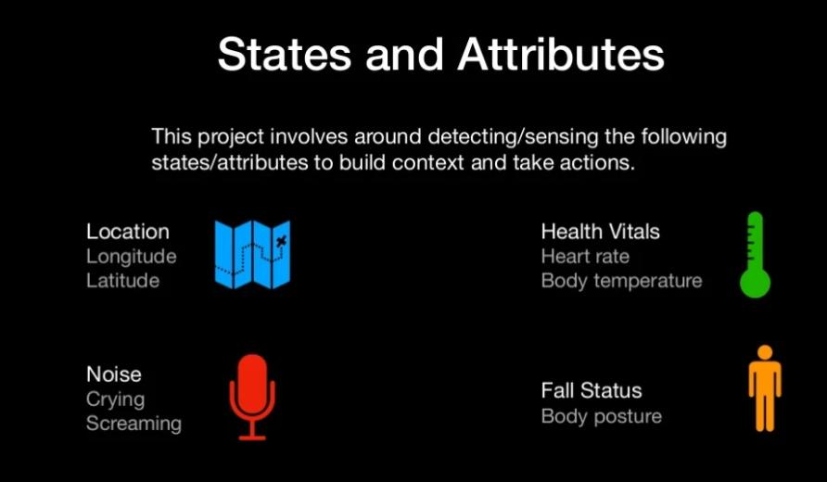Detecting and sensing:*

*Services to get the data:*

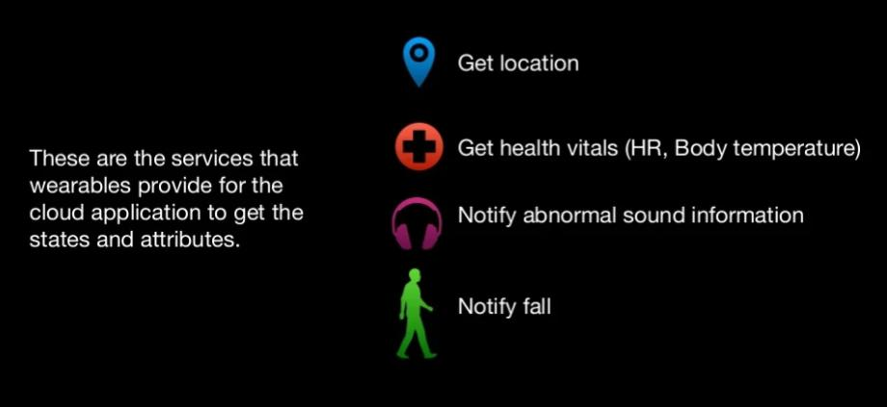

*Detecting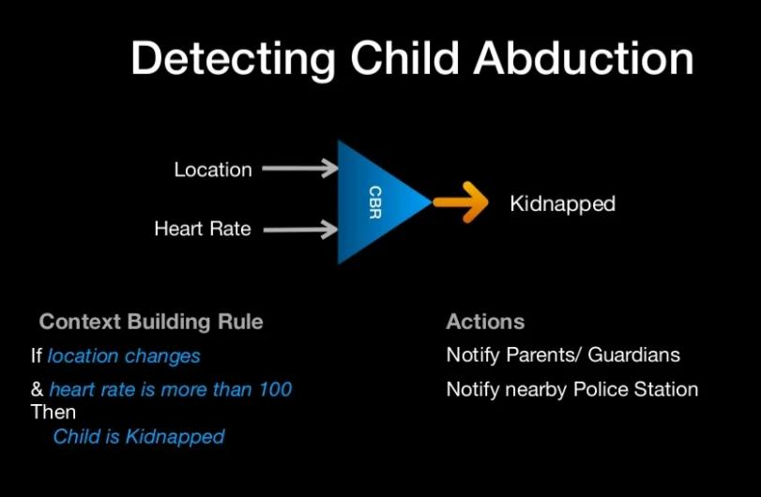*

*Python code to track the location:*

*From geopy.geocoders import Nominatim*

*Import time*

*From pprint import pprint*

*# instantiate a new Nominatim client*

*App = Nominatim(user_agent=”tutorial”)*

*# get location raw data*

*Location = app.geocode(“Nairobi, Kenya”).raw*

*# print raw data*

*Pprint(location)*

*Output*

*{‘boundingbox’: [‘-1.444471’, ‘-1.163332’, ’36.6509378’, ’37.1038871’],*

*‘class’: ‘place’,*

*‘display_name’: ‘Nairobi, Kenya’,*

*‘icon’: ‘https://nominatim.openstreetmap.org/images/mapicons/poi_place_city.p.20.png’,*

*‘importance’: 0.845026759433763,*

*‘lat’: ‘-1.2832533’,*

*‘licence’: ‘Data © OpenStreetMap contributors, ODbL 1.0. ‘*

*‘https://osm.org/copyright’,*

*‘lon’: ’36.8172449’,*

*‘osm_id’: 9185096,*

*‘osm_type’: ‘relation’,*

*‘place_id’: 273942566,*

*‘type’: ‘city’}*